Web Application Firewall Policy with ORM Stack

Contents
1. Introduction 3
2. Workflow diagram to deploy the stack 3
3. Create stack for WAF Policy 4
4. Plan the Job 8
5. Apply the Job 9
6. Verify in the Console 10

Introduction

Web application firewall (WAF) policies store configurations that include access control, rate limiting, and WAF security capabilities. These capabilities protect web applications from cyber attacks and insider attacks.

Workflow diagram to deploy the stack

Below diagram shows how the Terraform Artifact are applied in the OCI. While creating a ORM stack, using terraform deliverables Init, Plan and Apply is the flow to provision the resource in the OCI. We can have the deliverables in any of below.

- GitLab/GitHub Repo
- Bitbucket
- Can be in folder/.zip in the local disk
- Object Storage Bucket
- Can be in compartment
- Oracle provided Template



Create stack for WAF Policy

Go to OCI Console Developer Services Resource Manager Stacks select the compartment Create Stack

My Configuration Folder Browse Select the “WAF-policy” folder that contains the terraform Upload

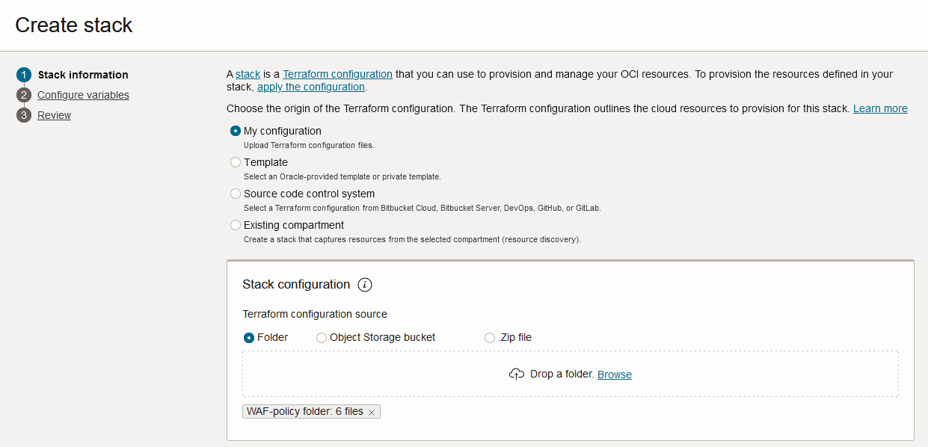

Select the parameters as per the below screens,
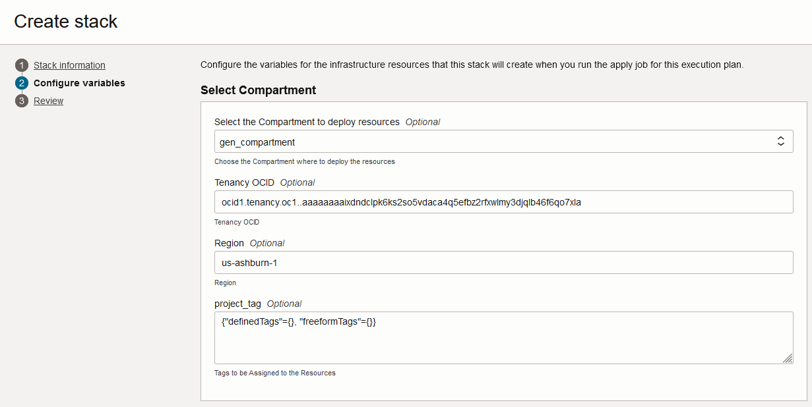
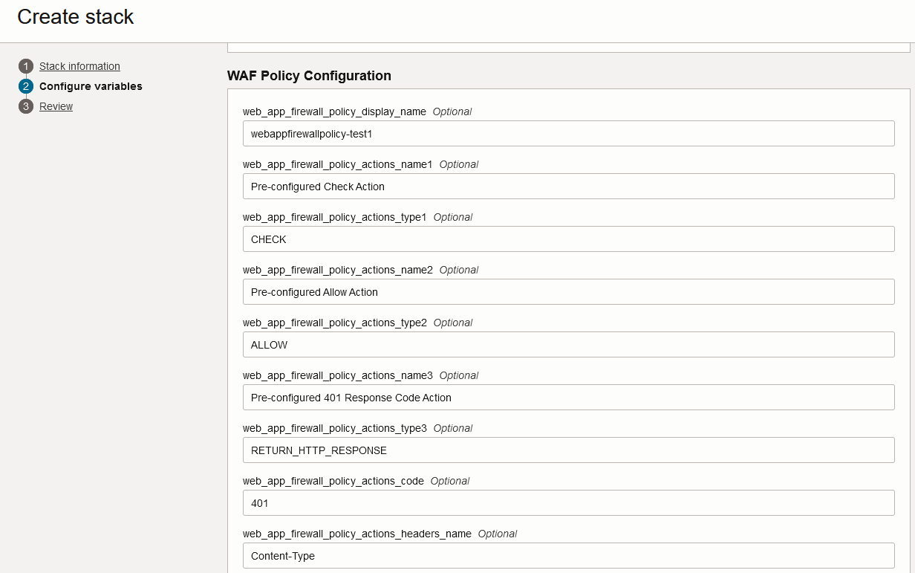

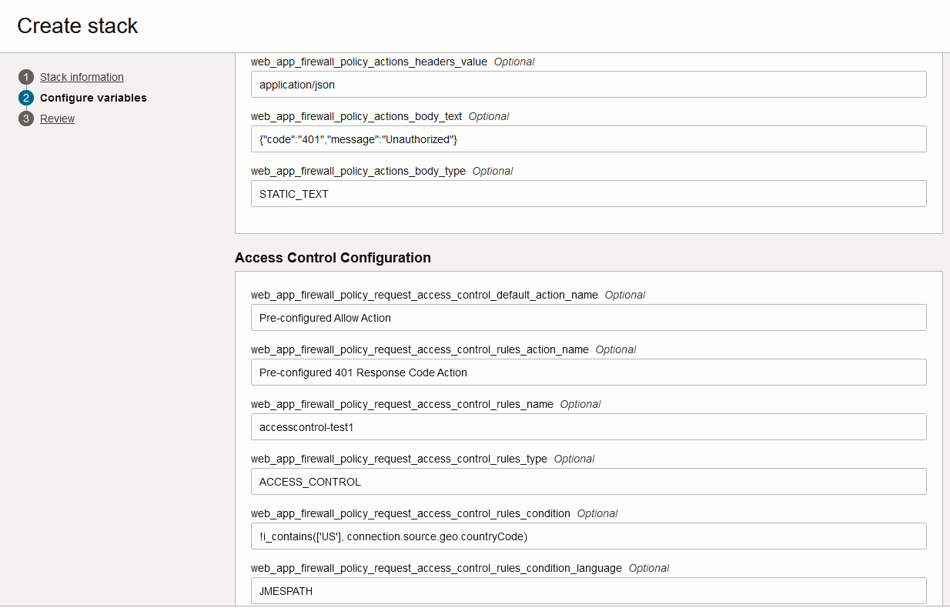
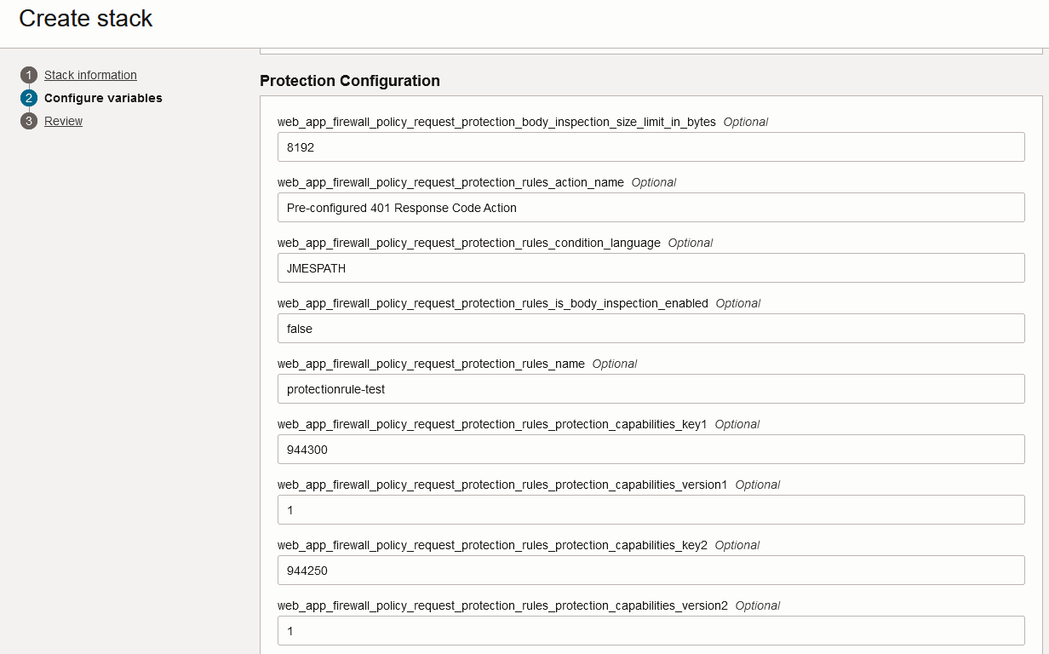

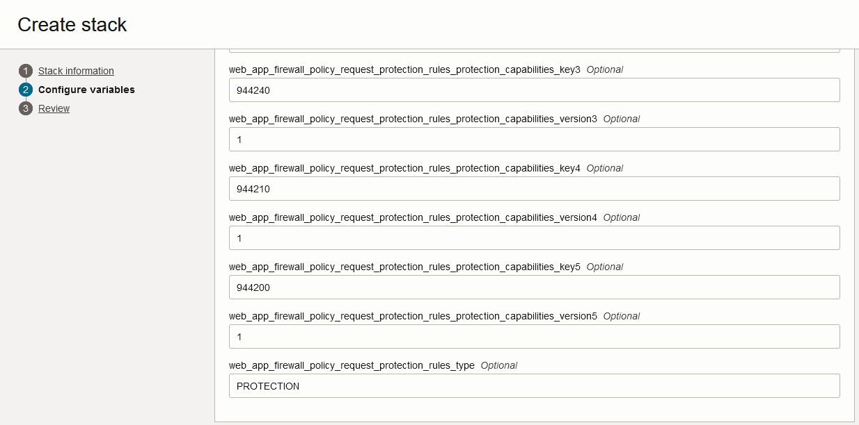
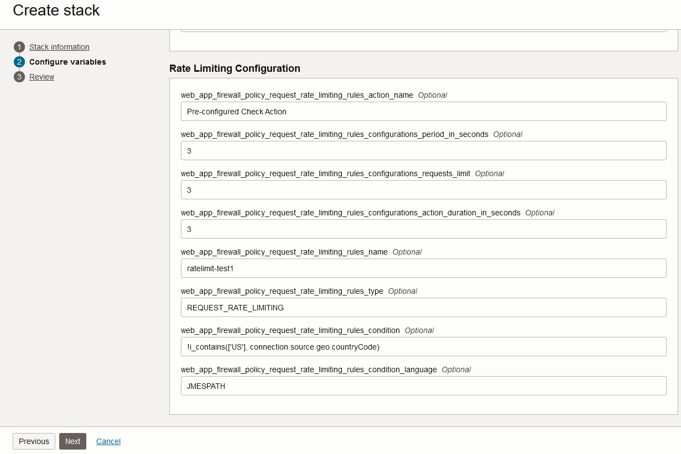
Click “Next”

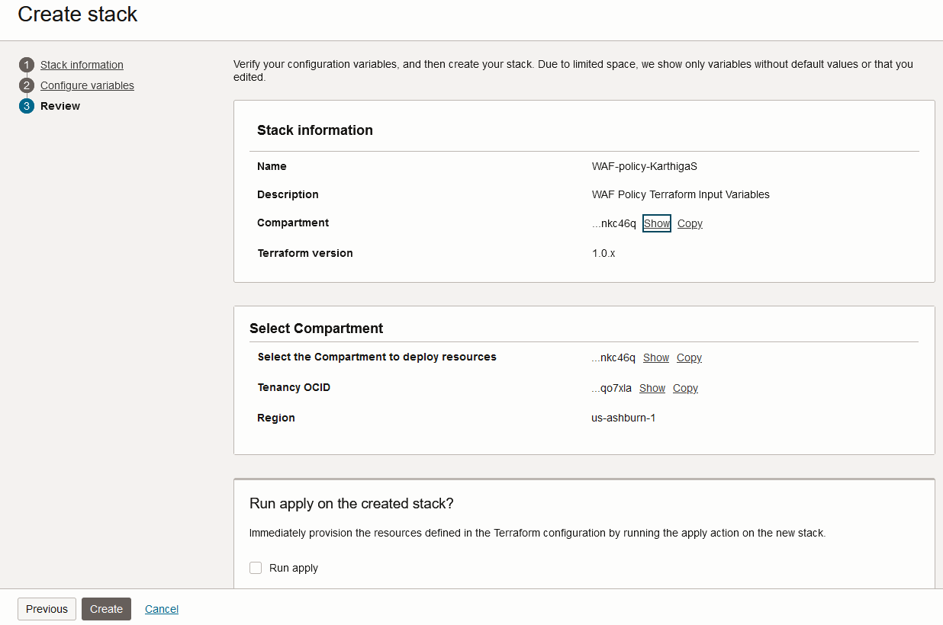
Click “Create”

Plan the Job

Click the “Plan”
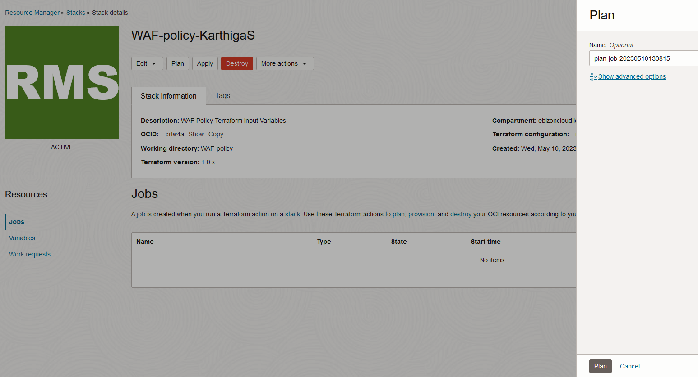

Verify the Plan is successful.

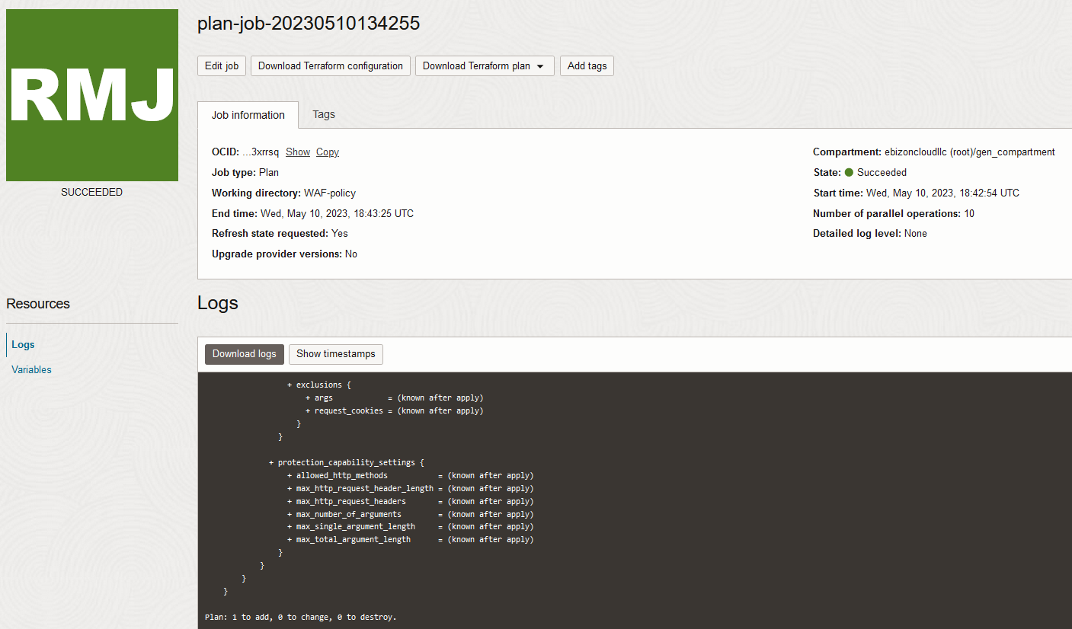

Apply the Job

Once the “plan” is success, now click “Apply”

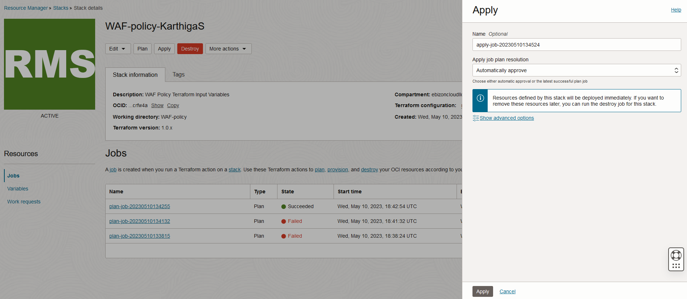

Verify the Apply is successful.

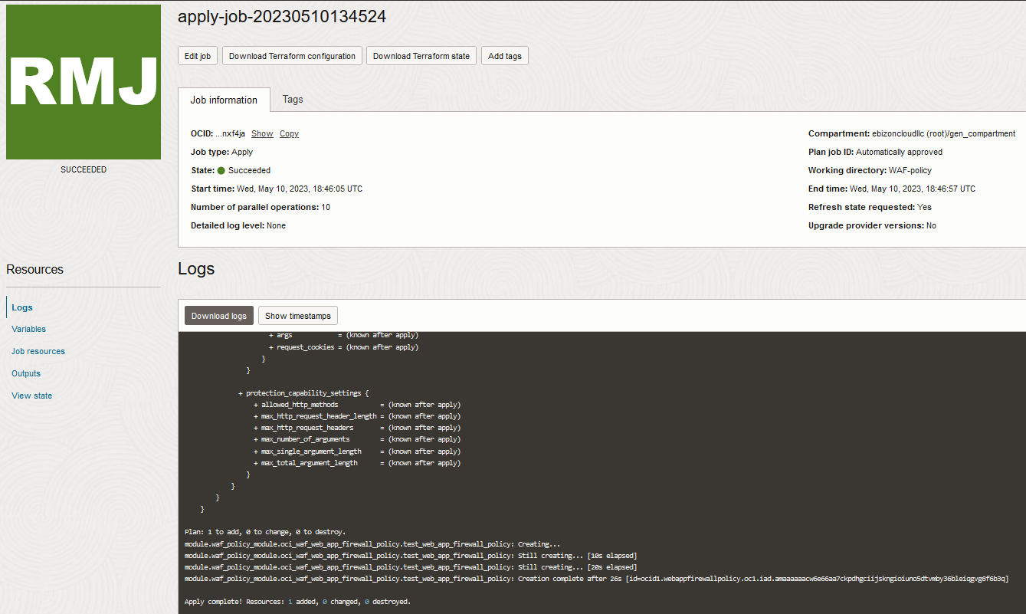

Verify in the Console

Go to OCI Console Web application firewall Policies

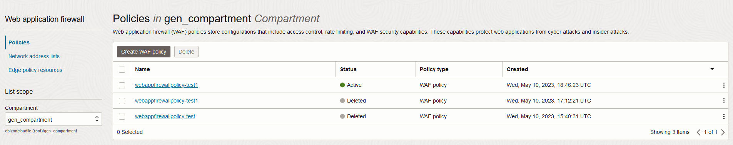

Web application firewall Policies Policy details

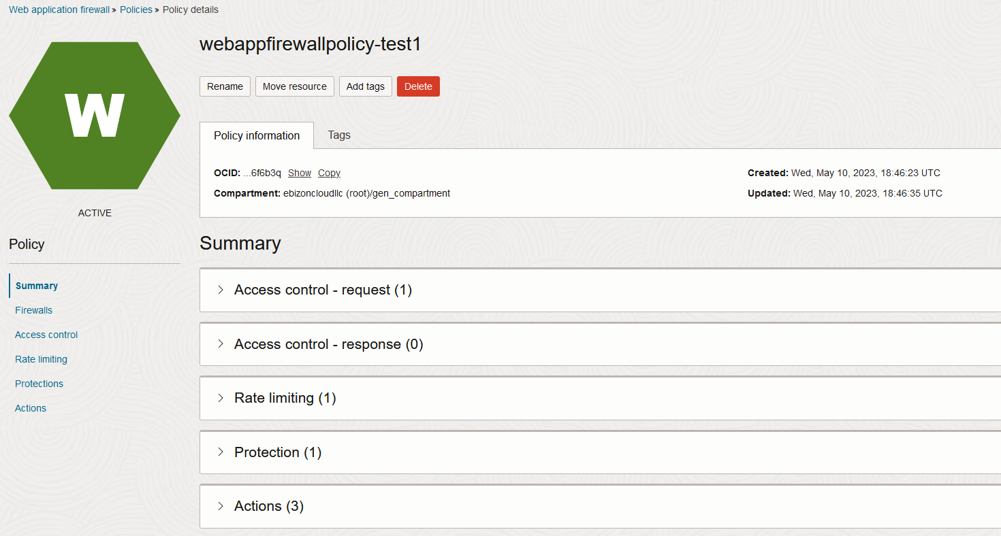

# END #

Contents
No table of contents entries found.

